**DINESH KUMAR**

**Retire Indian Army (Corps of Military Police)**  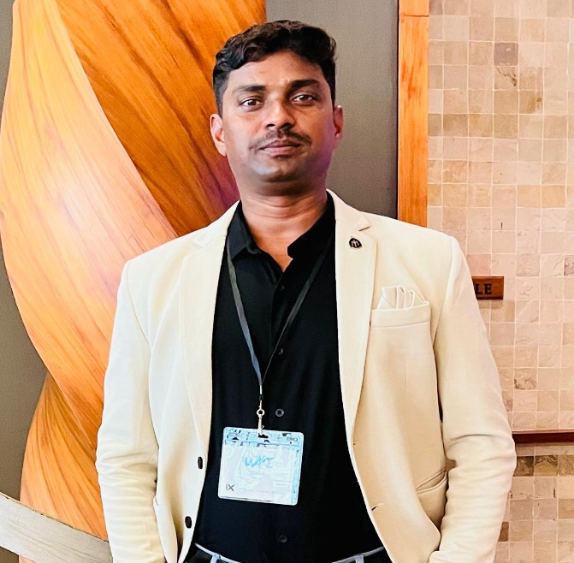

**CONTACT**

***MOB:- +91 7892657253,+91 8103488021***

***Email:-*** [***ddanuji992@gmail.com***](mailto:ddanuji992@gmail.com)

***Add:- Risali Bhatha Near By Shardha School Bhilainagar District- Durg***

***Chhattisgarh Pin:-490006***

**CERTIFICATIONS**

* ***Certificate Course in Basic Computer.***
* ***Military College of Telecommunication Engineering Mhow***

***Engineers And Military Police Regimental Signal (NCOs)***

* ***Security Training certificate.***
* ***Graduation Certificate INDIAN ARMY***
* ***Character Certificate***
* ***Certificate of Excellence (CORPS OF MILITARY POLICE CENTRE AND SCHOOL)***
* ***Testimonial for Civil Employment (COROS OF MILITARY POLICE AND SCHOOL)***
* ***Certificate of Attendance Gender in peace Keeping Operations (UNITED NATIONS INTERIM FORCE IN LEBANON)***

**EDUCATIONS**

* ***12th pass chhattisgarh Board 2003***
* ***Equivalent Graduation From Indian Army***

***INDIAN ARMY 11 jan 2004 To 31 jan 2021***

**AWARDS**

* ***OP Rakshak Medal (Indian Army)***
* ***The Secretary General of the United Nations Award (UINTED NATIONS INTERIM FORCE IN LEBANON)***
* ***M.B. area provost unit award***

**SKILLS**

* ***Investigation and Vigilance.***
* ***Traffic Management and Driving.***
* ***Police and security Duties.***
* ***Administration and Discipline*.**
* ***Creative spirit.***
* ***Reliable and Professional.***
* ***Organized.***
* ***Time Management.***
* ***Team Player.***
* ***Fast Learner.***
* ***Motivated.***
* ***Security And Fire Fighting.***
* ***Logistics, Supply Chain And Warehousing.***
* ***Material Planning and Stores Management.***
* ***Facilities Management Training Development.***
* ***Leading Manpower Across Various Functions.***
* ***Basic knowledge of all computer applications.***

**WORK EXPERIENCE**

* **Military Transport Section Supervisor.**
* **Network Marketing And Direct Selling.**

**DECLARATION**

***I hereby declare that the above mentioned information is correct up to my knowledge & I bear the responsibility for correctness of above mentioned particulars.***

***PLACE: BHILAI NAGAR NAME***

***(CHHATTISGARH) DINESH KUMAR***